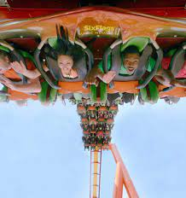

Europe to pricey? Don’t want to go to Mexico? Then join us on our annual Grad Getaway!!! What’s included? Transportation on luxury bus liners with WIFI, three nights at a HILTON property and all the great parks and activities included on this itinerary.

Day 1: Wednesday, May 31st, 2023

10:30 AM We depart for Sunny Southern California.

2:30 PM Late Lunch stop in Indio, CA (45 minute stop)

6:00 PM Arrive at The Anaheim Doubletree. Check in to your room and head over to the Outlets at Orange for shopping and eats, Lucky Strike Bowling, AMC or Dave and Busters! Or chill in your room, check out the pool and jaquzzi

Day 2: Thursday, June 1st, 2023

8:30 AM We depart from the Doubletree and head to Magic Mountain®

10:00 AM Arrive at Magic Mountain®, at 10:30:01AM the main gates will open and you can sprint to your favorite ride in the park. Admission includes one meal, snack and unlimited drink refills.

7:15PM Load and head back to the Doubletree.

8:45 PM Arrive back at the hotel and get a good night’s rest for your exclusive grad party at GRAD BASH 2023!

Day 3: Friday June 2nd
Spend the morning getting ready for departure to City Walk and your private Grad Party at Universal Studios.

12:00 PM Load and depart for Universal Studios® full of action-packed entertainment all in one place: thrilling theme park rides and shows, a real working movie studio, and LAs’ best shops, restaurants Specialty Shops, restaurants, food and drink and Cinemas at City Walk and plenty of time to explore before early entry to Universal.

4:00 PM Early entry for Grad Getaway participants to the ALL NEW GRADBASH Universal Studios. Headline entertainers, dance clubs and all the rides and attractions in an exclusive private party for the Class of 2023! Be sure to check out the show spectacular WATER WORLD during your early entry!

Day 4: Saturday, June 3rd
1:00 AM Load and head back to the Doubletree
10:00AM Up and at’em and get ready for Newport Beach’s Balboa Pier / Newport Harbor. Prepare for a day of beach fun including: shopping, biking, harbor cruises, jet-skis or beach games.

6:00 PM Load and head back to the Valley of the Sun.
9:00 PM Dinner stop in Indio, CA

Day 5: Sunday, June 4th
1:30 AM Arrive back home.
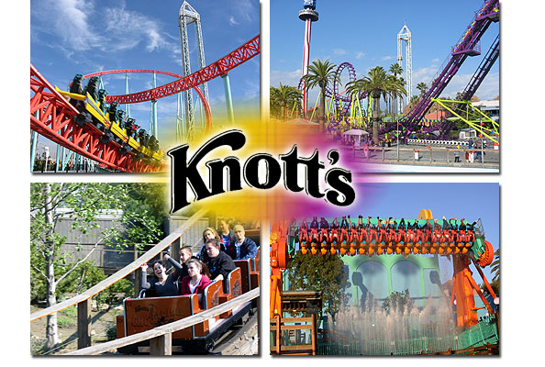

What are Grad Getaways???
* The ULTIMATE last gathering of
THE CLASS OF 2023!!!
* An awesome graduation present.
*An affordable, exciting, accessible to all
alternative to more expensive trips.
* The Ultimate Graduation Celebration!!!
* “Memories That Last a Lifetime”

Class of 2023’s Grad Getaway can be paid in full or set up in four convenient payments (Does NOT include food, (except lunch at Magic Mountain), shopping or personal expenses). Price is out of “The Valley”, per person (tax included), based on quad occupancy. We also offer nonlocal too, check for pricing.
(See reverse side for payment schedule).
How do we join the trip?
Get your $175 initial deposit (YOU CAN SIGN UP ANYTIME, THE SOONER THE BETTER) to your trip coordinator.
We take schools, small groups and individuals. To set up a presentation for your group, please contact us. Give us a call so we can organize a meeting for your school! Also, contact us for details on how to earn a FREE TRIP for organizing a new school!
CONTACT US:
Michael Gutierrez at 623-780-4621
GWIZZ Travel is based here in the Valley!!!
E-mail at; gwizztravel@gmail.com
WE ACCEPT CREDIT CARDS.
SEE REVERSE SIDE FOR DETAILS.

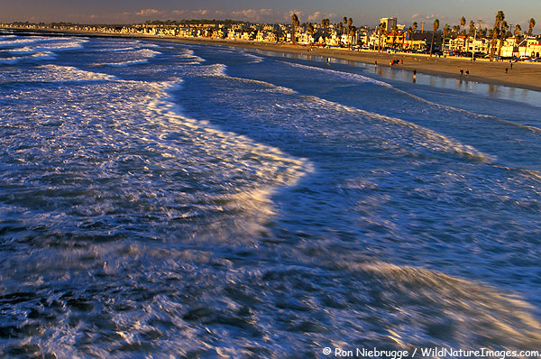

Check out our website at:
THIS IS NOT A DISTRICT SPONSORED TRIP.
CAMPUS ORGANIZER:

