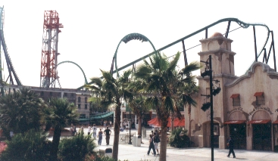

®

Can’t afford Europe? Don’t want to go to Mexico? Then join us on our Grad Getaway!!! What’s included? Transportation in luxury bus liners, with onboard movies en route, two nights at HILTON, HYATT, SHERATON, OR WYNDHAM properties and all the venues included on this itinerary.

Day 1: Wednesday, May 30th , 2018
4:00 AM We will depart from Arrowhead Mall in the Dillard’s upper NW parking lot. Please verify your departure location with your sponsor. After loading the bus and covering the pre-flight checklist, we will be on our way!

8:00 AM Breakfast stop in Thousand Palms, CA
11:30 AM Newport Beach’s Balboa Pier / Newport Harbor. Prepare for a day of beach fun including: shopping, biking, harbor cruises, jet-skis or beach games.
6:30 PM Load and head to the hotel.
7:30 PM Arrive at your hotel, (Doubletree (Hilton family), Hyatt, Sheraton, Crown Plaza) situated next to shopping, trendy restaurants, fast food and other amenities. Or just hang out and enjoy the jacuzzi, pool or other hotel amenities.

Day 2: Thursday, May 31st
8:30 AM Rise and shine and load the busses for a great day at Knotts Berry Farm®. Check out all the latest rides or jump on the classics.

3:00 PM Load and depart for Universal Studios® full of action-packed entertainment all in one place: thrilling theme park rides and shows, a real working movie studio, and Los Angeles’ best shops, restaurants and cinemas at CityWalk. Universal Studios Hollywood is a unique experience! Check out more at
http://www.universalstudioshollywood.com/theme-parks/

4:45 PM Arrive at the all-new GRADBASH Universal Studios.

Day 3: Friday, June 1st

1:30 AM Load and head back to the Doubletree
10:00 AM After a room inspection load buses at 10:45 AM
11:00 AM Depart for Six Flags Magic Mountain® arrive at noon and you can sprint to your favorite ride in the park.

8:00 PM Leave Magic Mountain and head for home.
11:00 PM Dinner stop in Thousand Palms, CA

Day 4: Saturday, June 2nd
3:30 AM Arrive back in the Valley.
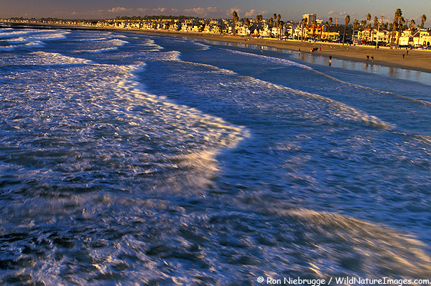
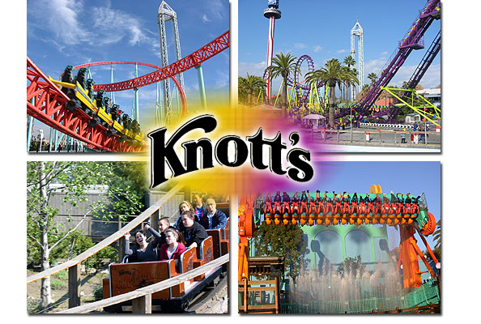

What do I need to bring???
Use the itinerary as a guideline for your packing
- Clothing: Dress for the weather! Check out the weather for Anaheim and Valencia on our website! Something warm, the O.C. is cooler than AZ, especially at night., jeans, a swimsuit, sunglasses, a hat.

- The extras: sun block, toiletries, cameras, cell phones ( to call parents for pick-up), a pillow, blanket and DVD movies for the bus ride.

- A credit card: The Anaheim/Orange DoubleTree requires a credit card for any room service, movies, video game rentals and telephone use and emergencies.

- FOOD MONEY
- $3.00 FOR BUS GRATUITY
- ID and Signed GWIZZ Permission/ Medical Information Form
- Universal Studios Release Form

Michael at 623-780-4621
GWIZZ Travel is based here in the Valley!!!
e-mail at; gwizztravel@gmail.com

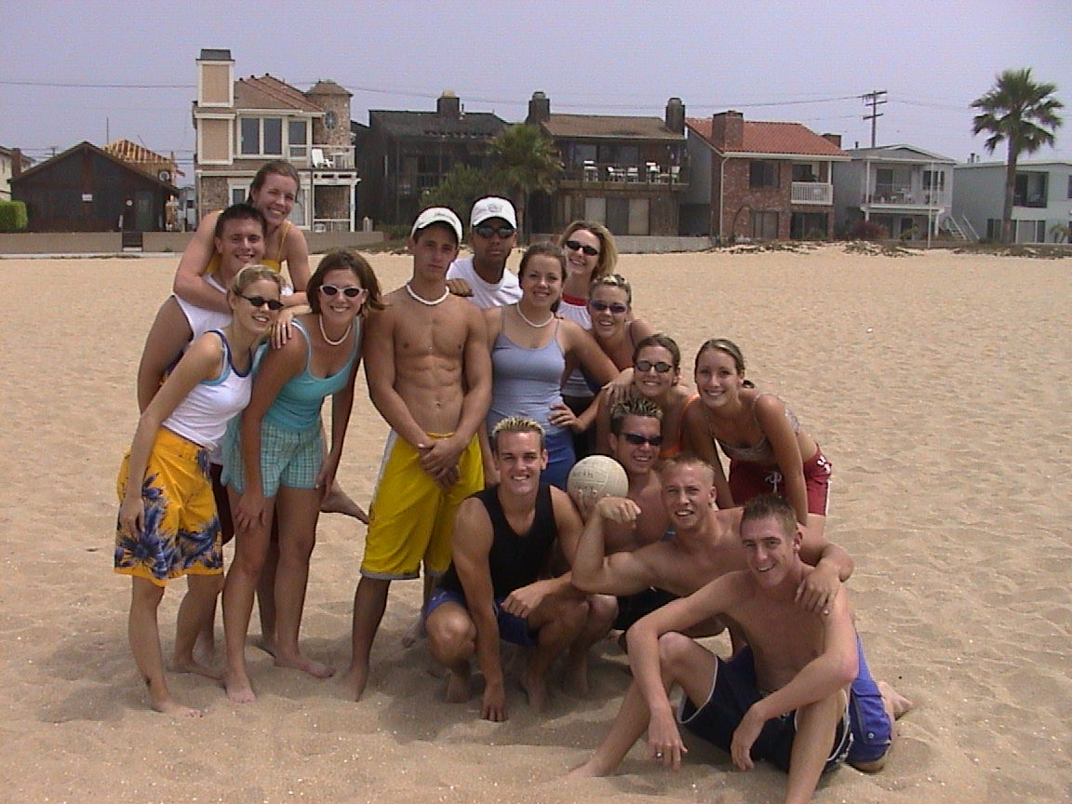

Check out our website at:
Check out our FACEBOOK page. Search GWIZZ Travel and checkout our videos and information. Be sure to suggest our page to your friends.
THIS IS NOT A DISTRICT SPONSORED TRIP.
Bring 2, 20 or 200 of your closest friends for “Memories That Last
a Lifetime.”
CAMPUS ORGANIZER:

