®

Can’t afford Europe? Don’t want to go to Mexico? Then join us on our Grad Getaway!!! What’s included? Transportation in luxury bus liners, with onboard movies en route, two nights at HILTON, HYATT, SHERATON, OR WYNDHAM properties and all the venues included on this itinerary.

Day 1: Wednesday, May 30th , 2018
1:30 AM We will depart from your parking lot or other location depending on your school. Please verify your departure location with your sponsor. After loading the bus and covering the pre-flight checklist, we will be on our way!
4:00 AM Short stop in Phoenix (Driver change)
8:00 AM Breakfast stop in Thousand Palms, CA
11:30 AM Newport Beach’s Balboa Pier / Newport Harbor. Prepare for a day of beach fun including: shopping, biking, harbor cruises, jet-skis or beach games.
6:30 PM Load and head to the hotel.
7:30 PM Arrive at your hotel, (Doubletree (Hilton family), Hyatt, Sheraton, Crown Plaza) situated next to shopping, trendy restaurants, fast food and other amenities. Or just hang out and enjoy the jacuzzi, pool or other hotel amenities.

Day 2: Thursday, May 31st
8:30 AM Rise and shine and load the busses for a great day at Knotts Berry Farm®. Check out all the latest rides or jump on the classics.
3:00 PM Load and depart for Universal Studios® full of action-packed entertainment all in one place: thrilling theme park rides and shows, a real working movie studio, and Los Angeles’ best shops, restaurants and cinemas at CityWalk. Universal Studios Hollywood is a unique experience! Check out more at
http://www.universalstudioshollywood.com/theme-parks/

4:45 PM Arrive at the all-new GRADBASH Universal Studios.

Day 3: Friday, June 1st
1:30 AM Load and head back to the Doubletree
10:00 AM After a room inspection load buses at 10:45 AM
11:00 AM Depart for Six Flags Magic Mountain® arrive at noon and you can sprint to your favorite ride in the park.

8:00 PM Leave Magic Mountain and head for home.
11:00 PM Dinner stop in Thousand Palms, CA

Day 4: Saturday, June 2nd
4:00 AM Short Stop in Phoenix (Driver change)
6:30 AM Arrive Home

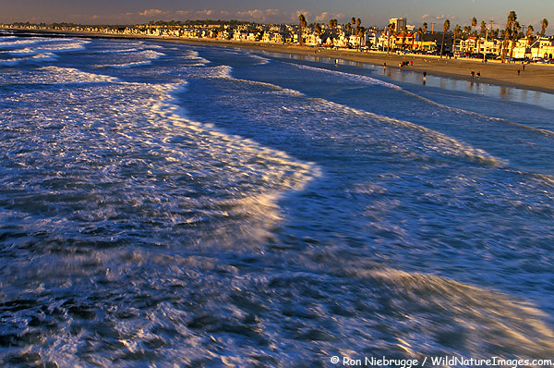

What are Grad Getaways???
* The hottest grad trend in AZ.
* An awesome graduation present.
*A safe alternative to Mexico trips.
* The Ultimate Road Trip!!!
* “Memories That Last a Lifetime”

The amount can be paid in full or set up in three convenient payments (Does NOT include food, shopping or personal expenses).
(See reverse side for payment schedule). Contact your campus organizers or us for more info.

How do we join the trip?
Get your $140 initial deposit (YOU CAN SIGN UP ANYTIME, THE SOONER THE BETTER) to your trip coordinator.
We take schools, small groups and individuals. For a free informational video and to set up a presentation for your group, please contact one of our reps. Give us a call so we can organize a meeting for your school! Also, contact us for details on how to earn a FREE TRIP!
CONTACT US:
Michael Gutierrez at 623-780-4621
GWIZZ Travel is based here in the Valley!!!
E-mail at; gwizztravel@gmail.com
WE ACCEPT CREDIT CARDS.
SEE REVERSE SIDE FOR DETAILS.

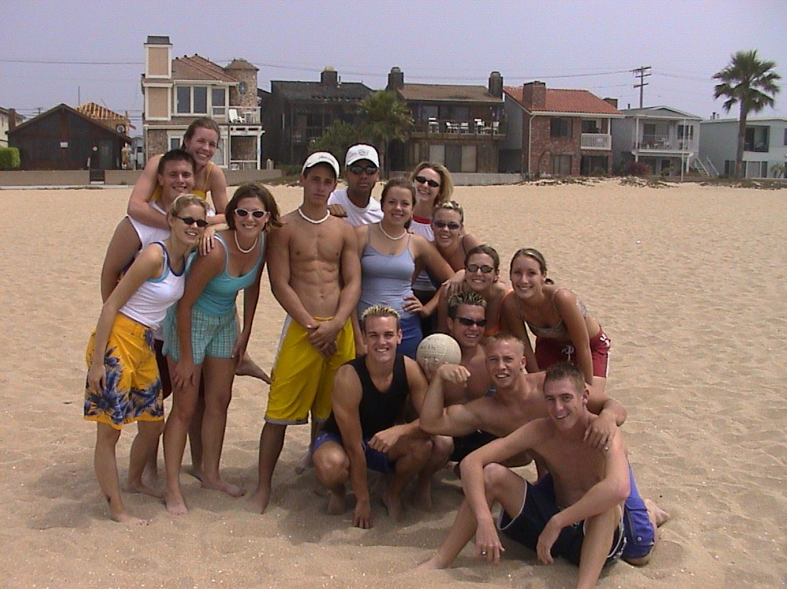

Check out our website at:
Check out our FACEBOOK page. Search GWIZZ Travel and checkout our videos and information. Be sure to suggest our page to your friends.
THIS IS NOT A DISTRICT SPONSORED TRIP.
Bring 2, 20 or 200 of your closest friends for “Memories That Last
a Lifetime.”
CAMPUS ORGANIZER:

